Software Requirements Specification

for

Mnemosyne App

Version 1.1

**Prepared by**

Michael Le, Prince Antwi Aboagye, Damion Sevilla,

Austin Johnson, Debashis Jena, Didimus Kimbi

Team Charlie

06/28/2021

**Table of Contents**

**Table of Contents i**

**Revision History** **ii**

**1.** **Introduction 1**

1.1 Purpose 1

1.2 Document Conventions 1

1.3 Intended Audience and Reading Suggestions 1

1.4 Product Scope 1

1.5 References 2

**2.** **Overall Description 2**

2.1 Product Perspective 2

2.2 Product Features 2

2.3 User Classes and Characteristics 3

2.4 Operating Environment 3

2.5 Design and Implementation Constraints 3

2.6 User Documentation 4

2.7 Assumptions and Dependencies 4

**3.** **System Features 4**

3.1 Record Speech 4

3.2 Record Speech of the User Only 4

3.3 Voice Recognition Training 4

3.4 Save and Retain Text 4

3.5 Searching Text 4

3.6 Visual Options 5

3.7 Training Videos 5

3.8 Send Notification to User 5

**4.** **External Interface Requirements 5**

4.1 User Interfaces Overview 5

4.2 Hardware Interfaces 5

4.3 Software Interfaces 5

**5.** **System Features/Modules 6**

5.1 Record Speech 6

5.2 Record Speech of the User Only 6

5.3 Voice Recognition Training 7

5.4 Save and Retain Text 7

5.5 Searching Text 8

5.6 Visual Options 8

5.7 Training Videos 9

5.8 Send Notification to User 9

**6. Non-functional Requirements……………………………………………………………….10**

6.1 Storage………………………………………………………………………………………...10

6.2 Security………………………………………………………………………………………..10

6.3 Usability……………………………………………………………………………………….10

6.4 Performance…………………………………………………………………………………...10

6.5 Maintainability………………………………………………………………………………...10

**Revision History**

|  |  |  |  |
| --- | --- | --- | --- |
| **Name** | **Date** | **Reason For Changes** | **Version** |
| Charlie Team | 06/11/2021 | Initial Document | 1.0 |
| Charlie Team | 06/28/2021 | Revise Document | 1.1 |
|  |  |  |  |
|  |  |  |  |
|  |  |  |  |

# Introduction

## Purpose

Due to the rise in the number of short-term memory disabilities in the United States, United Global Coders (Charlie Team) proposes developing a mobile application recognizing the user's speech. Its purpose is to engage in conversation and help them live a fuller life despite their disability. The Short-Term Memory Assistant App will enable the user (disabled person) to remember meaningful conversations and ideas. The application shall be tuned into ignoring everything except what the user speaks, covering the speech to text, which shall save for a maximum of 1 week. There is a facility in the App to allow the user to train the App on its voice/key phrases, and by so making the application should recognize distinct phrases and sentences of the user. Users can always retrieve texts via a search command. Training videos are provided within the App to guide the user regarding its various features and functionalities. The purpose of this Software Requirement Specification is to give an overview of the functional and non-functional requirements of the Short-Term Memory Assistant App.

## Document Conventions

N/A

## Intended Audience and Reading Suggestions

This document is for the entire product team, especially the project manager, developers, and QA personnel.

## Product Scope

The purpose of the Short-Term Memory Assistant mobile application is to help people with short-term memory disabilities recognize their speech as they engage in conversation. The App will enable users to remember meaningful conversations and ideas.

The application allows users to:

* Edit any speech converted to text.
* Have a flexible environment for the user to customize.
* Train the App on its voice and critical phrases.
* Save texts to the local device for a maximum of 1 week.
* Search through the saved speech to a text note.
* Retrieve all results related to the search command.
* Learn the features and functionalities of the App by providing training videos within the App.

The functions listed above will help provide convenience to disabled people when going about their daily lives. The disabled user can remember meaningful conversations and ideas.

This mobile application aims to provide a solution for the critical and undeserved market segment to have a solution that meets their need for memory assistance. The application runs offline without connection to any server.

## References

Kick-Off Meeting, SWEN 670, Software Engineering Project, Course Homepage .

https://learn.umgc.edu/d2l/le/news/583665/2229119/view

Wiegers, K. (2002, October 21). IEEE 830 Software Requirements Specification Example 2. Retrieved September 28, 2020, from <https://learn.umgc.edu/d2l/le/content/512949/viewContent/19981483/View>

IEEE-SA Standards Board, O. (1998, June 25). IEEE Recommended Practice for Software Requirements Specifications. Retrieved October 09, 2020, from <https://learn.umgc.edu/d2l/le/content/512949/viewContent/18971317/View>

# Overall Description

## Product Perspective

The mobile app team's goal is to create a Short-Term Memory Assistant mobile application that assists users with short-term memory issues. The function of the application includes recognizing the speech of the user and speech patterns in conversation to help the user in everyday life. The mobile application begins by authenticating the user. It can accomplish through login or face recognition. Login credentials have the option of being saved if face recognition is not available on their mobile device due to the nature of the user's condition. After user authentication, the NLP will identify the user's voice. The device mic will stream speech data to the AWS Streaming Transcription. The data stream will collect into a final response, and the speech will save as text data in the app folders with a timestamp. The user can review the saved text files and edit them as needed at any point in time. The App will have an Accessibility settings page for altering text size, app colors, etc. There will be training videos within the App to help teach the user how to use the application's various functions.

## Product Features

The Mnemosyne app consists of the following modules:

* Training Videos
* Record Speech of the User only
* Voice Recognition Training
* Record Speech
* Save and Retain Text
* Searching Text
* Visual Options
* Send Notification to the User

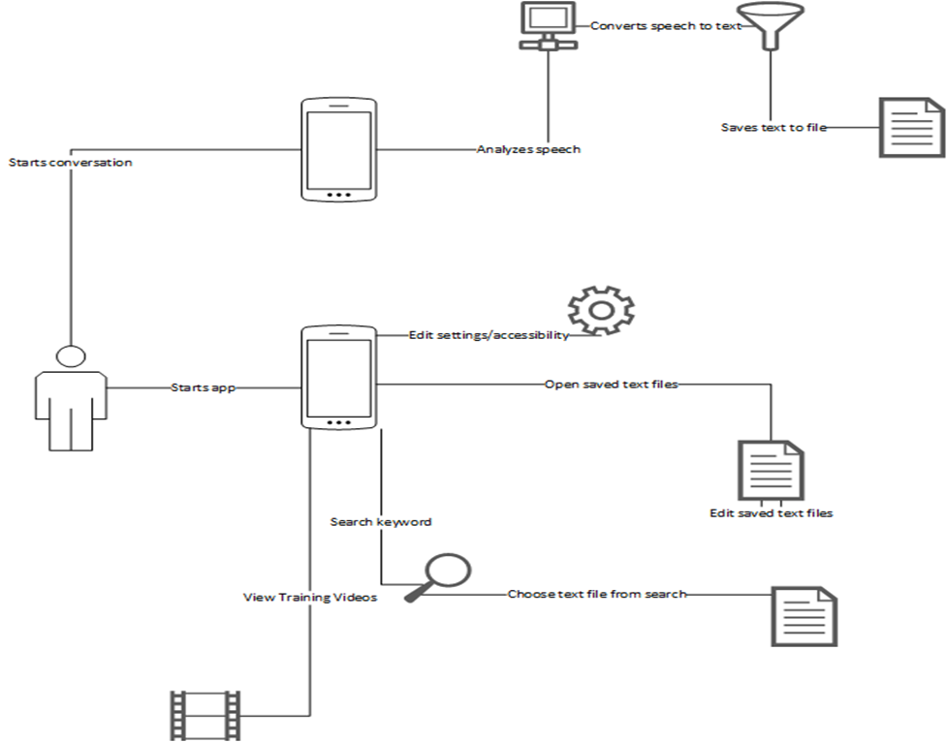

Figure 2.2: Data Flow Diagram

## User Classes and Characteristics

Standard users are thought to be persons with short-term memory disabilities and potential developers.

Person(disability) – This class of users might not know anything about phone applications, so the system needs to be quite simple and easy to use.

Potential Developers – Potential developers need a high level of expertise to understand

phone applications.

Due to the characteristics of user classes, stability and customization of this software are incredibly important.

## Operating Environment

OE-1: The Mnemosyne application shall operate on phones with both iOS and Android operating systems.

## Design and Implementation Constraints

CO-1: The user interface is limited to the English Language.

## User Documentation

UD-1: There will be training videos with understandable and straightforward graphics on how the system works.

## Assumptions and Dependencies

AS-1: The system shall listen to the user's speech only without any interruptions from other parties.

DE-1: The system shall rely on battery power, sound, and the prescribed operation system to function.

# System Features

## Record Speech

Given that the user has opened the Mnemosyne app, this feature allows the user to start recording, pause(resume) recording, and stop (Cancel) recording.

## Record Speech of the User Only

Given that the user has opened the Mnemosyne app, this feature records the user's speech only, ignoring the other users involved in a conversation.

## Voice Recognition Training

Given that the user has opened the Mnemosyne app, this feature serves as a display and functionality of user voice pattern recognition. The user's voice is used as the baseline for future NLP (Natural Language Processing) in the system.

## Save and Retain Text

Given that the user has opened the Mnemosyne app, this feature saves critical information via key phrase activation.

## Searching Text

The user has opened the Mnemosyne app, and this feature allows the user to search through their saved dialog scripts to find a specific text phrase.

## Visual Options

Given that the user has opened the Mnemosyne app, this feature allows the user to access a menu to manipulate the application's visual appearance. It includes text size and boldness, and zooming in the entire application.

## Training Videos

Given that the user has opened the Mnemosyne app, this feature allows the user to access videos within the application that will teach users how to use the application.

## Send Notification to User

Given the user has saved text successfully with an upcoming event, this feature sends a notification to the user to remind them of an event.

# External Interface Requirements

## User Interfaces Overview

UI-1: The user interface of the system shall be text-based.

UI-2: The system shall have dropdowns under the text size, zoom, boldness level for easy customization of the interface. These dropdowns will prevent the user from making errors.

UI-3: The system shall be easy to navigate with the help of training videos. Training videos included in the system will be clear and understandable.

## Hardware Interfaces

N/A

## Software Interfaces

4.3.1 For optimum viewing and functionality of mobile applications. Mnemosyne mobile app features are available when running on both Android and iOS operating systems.

4.3.2 Mnemosyne application will be available in both Google Play Store and Apple Store for download.

4.3.3 The Mnemosyne application shall encrypt data at rest for security purposes.

# System Features/Modules

## Record Speech

5.1.1 Description and Priority

A Mnemosyne app user may start recording, pause the recording and end speech recording.

5.1.2 Stimulus/Response Sequences

Stimulus: The actor opens the Mnemosyne application in the cell phone and stays close to the phone or the connected microphone.

Response: The system displays the main application page with the microphone icon and a read-only text area

Stimulus: The actor clicks the microphone icon to activate the recording of the speech and starts speaking or a normal conversation.

Response: The system starts converting the speech to text and displays it in the text area above the buttons. The system should also display three other buttons; pause, stop and cancel.

Stimulus: The User clicks the pause button.

Response: The speech-to-text conversion is paused, and none of the speech converts to text. The application displays a resume button and a cancel button.

Stimulus: User clicks Resume button

Response: The system displays the previous page with a pause, stop and cancel button. The speech-to-text conversion is resumed.

Stimulus: The User clicks the stop button.

Resume: The speech-to-text conversion is stopped and saved in the phone's local memory and displays the first screen again with the microphone

Stimulus: User clicks Cancel button.

Response: The system cancels all the speech-to-text conversion and saves nothing.

5.1.3 Functional Requirements

REQ-1.1: Upon a user opening the Mnemosyne app, the system shall display the homepage of the Mnemosyne app by showing the microphone icon and read-only text area.

REQ-1.2: As the user starts recording speech, the speech converts to text at the text area with Start, Pause, and Cancel recording buttons showing below it.

REQ-1.3: While recording speech, if the user clicks on the Pause button, the system stops converting speech to text. The Resume button shall appear below the screen for the user to resume recording.

REQ-1.4: As the user clicks the resume button, the system shall enable the user to continue recording by displaying the previous page with the Pause, Stop, and Cancel button.

REQ_1.5: If the user clicks on the stop button, the system automatically saves the converted text and redirects the user back to the recording screen.

REQ-1.6: If the user wants to abort the process, the system clears the text and saves nothing by clicking on the Cancel button.

## Record Speech of the User Only

5.2.1 Description and Priority

A Mnemosyne app shall only record the user's voice and ignore other voices during conversations with other parties.

5.2.2 Stimulus/Response Sequences

Stimulus: The actor opens the Mnemosyne application on the cell phone, starts a conversation, and clicks the microphone icon to activate the recording.

Response: The system recognizes the user's voice and converts the user's speech only to text. The system saves the text periodically in folders by date and time.

5.2.3 Functional Requirements

REQ-2.1: Upon a user opening the Mnemosyne app and clicking on the microphone icon to start recording speech, the system recognizes only the user's speech and converts it to text. The system shall save the text by date and time for easy retrieval.

## Voice Recognition Training

5.3.1 Description and Priority

The display and functionality of the user's voice pattern have recognition. The user's voice is used as the baseline for future NLP (Natural Language Processing) in the system.

5.3.2 Stimulus/Response Sequences

Stimulus: The actor taps on the speech button on the screen.

Response: The system begins listening to the user's voice. The screen displays and annotates on screen-detected speech. The system creates a baseline from the detective speech pattern.

Stimulus: The actor sets key phrases for *saving* important information. The actor Press and hold the speech button to record key phrase to be used. [Example: Memorized].

Response: The system will validate the chosen key phrase*.* The system displays the main screen and reading activation with the key phrase.

5.3.3 Functional Requirements

REQ-3.1: Upon a user opening the Mnemosyne app and clicking on the microphone app, the system starts tracking the user's voice. When the system detects the user's voice, it converts to text and creates a baseline for the detected speech pattern.

REQ-3.2: To set key phrases to save important information, the user shall press and hold the speech button to record the key phrase. After recording the key phrase, the system validates the key phrase by showing a checkmark.

## Save and Retain Text

5.4.1 Description and Priority

A Mnemosyne app may display and functionality of saving critical information via key phrase activation.

5.4.2 Stimulus/Response Sequences

Stimulus: The actor triggers key phrases and follows with crucial information

Response: The system will end and save text translation with any natural break in voice detection after recording critical information.  The system will save text to a local file for later retrieval by timestamp. The system saves files with weekly rollover.

5.4.3 Functional Requirements

REQ-4.1: After the system converting a speech to text by detecting a key phrase, the system shall display a checkmark with a "Saved" word appearing beside the text. By displaying the word saved and checkmark, the user will know if the text is saved or not.

## Searching Text

5.5.1 Description and Priority

A Mnemosyne app user may search through their saved dialog scripts to find a specific text phrase.

5.5.2 Stimulus/Response Sequences

Stimulus: The actor taps the search button at the bottom of the application

Response: The system displays a menu for the user to enter search criteria, including the search phrase and the time/date range.

Stimulus: The actor enters search information and then taps the search button.

Response: The system will search for the entered phrase within the entered timeframe and return dialog scripts with these phrases.

Stimulus: The actor taps one of the scripts.

Response: The system will open the chosen script with the search phrase bolded through the script.

5.5.3 Functional Requirements

REQ-5.1: Upon the user saving a text in the system successfully, by clicking on the search "S" button, the system displays "Start Time/Date," "End Time/Date," "Search Phrase" text box, and "Search" button.

REQ-5.2: If the user completes fields and clicks on "Search," the system will retrieve and display results.

REQ-5.3: When the user chooses a script and clicks on it, the system displays the text in bold font.

## Visual Options

5.6.1 Description and Priority

A Mnemosyne app user may access a menu where they can manipulate the visual appearance of the application. It includes text size and boldness, and zooming in the entire application.

5.6.2 Stimulus/Response Sequences

Stimulus: The actor taps the options button at the bottom of the application.

Response: The system will open the options menu, which includes several different categories of options that can change.

Stimulus: The actor taps the Appearance button.

Response: The system will open the visual appearance options where the user can change the text size and boldness and the zoom of the overall application.

Stimulus: The actor alters one or more of the options and taps the Change button.

Response: The system will open a confirmation dialog, ensuring that the user wants to make these changes.

Stimulus: The actor taps the Cancel button.

Response: The system returns to the visual appearance options screen without any changes.

Stimulus: The actor taps the Confirm button.

Response: The system returns to the visual options screen after applying the chosen settings.

5.6.3 Functional Requirements

REQ-6.1: Upon the user saving a text in the system successfully, by clicking on the option "O" button, the system shall display "Appearance" and "Training Videos."

REQ-6.2: If the user clicks on "Appearance", the system shall display dropdowns for "text size", "zoom", "Boldness level", "Change", and "Back" button

REQ-6.3: As the user makes changes and clicks on the Change button, the system shall display the message, "Are you sure you want to make these changes?" with the "Confirm" and "Cancel" buttons.

REQ-6.4: If the user clicks on the "Cancel" button, the system shall abort the process and redirect to the "Appearance" page without any changes.

REQ-6.5: If the user clicks on the "Confirm" button, the system shall save the changes and redirects the user to the "Appearance" screen.

## Training Videos

5.7.1 Description and Priority

A Mnemosyne app user access several videos within the application that will teach users how to use the application.

5.7.2 Stimulus/Response Sequences

Stimulus: The actor taps the options button at the bottom of the application

Response: The system will open the options menu, which includes several different categories of options that can change.

Stimulus: The actor taps the Training Videos button.

Response: The system will open the Training Videos screen, which includes a list of training videos.

Stimulus: The actor taps a particular training video.

Response: The system will open a new screen where the chosen training video plays.

Stimulus: The actor taps the Back button.

Response: The system will return to the Training Videos screen.

5.7.3 Functional Requirements

REQ-7.1: Upon the user saving a text in the system successfully, by clicking on the option "O" button, the system shall display "Appearance" and "Training Videos."

REQ-7.2: As the user clicks on the "Training Videos" button, the system shall display all lists of training videos.

REQ-7.3: If the user chooses a training video and clicks on it, the system shall start playing it.

REQ-7.4: As the user clicks on the "Back" button, the system shall redirect the user to the "Options" screen.

## Send Notification to User

5.8.1 Description and Priority

A Mnemosyne app may send notifications to the user to remind the user of an event.

5.8.2 Stimulus/Response Sequences

Stimulus: The actor saves a text in the system, including the date and time of an upcoming event.

Response: The system shall send a notification to the user 5 minutes before the upcoming event.

5.8.3 Functional Requirements

REQ-8.1: Upon the user saving a text in the system successfully involving the date and time of an upcoming event, the system shall detect the duration of the event and send a notification to the user 5 minutes before time.

## 6. Non-functional Requirements

## 6.1 Storage

NF-1.1: The application shall not save any voice recording but will save speech-to-text conversions on local storage.

NF-1.2: User's free up space in the storage. The application shall retain speech to text recognition for just a week.

## 6.2 Security

NF-2.1: For security reasons, the application shall encrypt data at rest.

## 6.3 Usability

NF-3.1: The proper user interface, training videos, and text user interfaces efficiently assist users in navigating the system without any problem.

NF-3.2: The application shall keep the end-user persona in mind for UI/UX considerations and offer a flexible environment for the user to customize.

## 6.4 Performance

NF-4.1: The boost performance and speed of the application and speech-to-text conversions shall only be retained in the local storage for just a week.

## 6.5 Maintainability

NF-5.1: There shall be design documents describing the internal works of the software.